Comp 3710

Assignment 6

Zikun Xu

Guide for user:

I build my app on Android 10.0. So, user need Android 10.0 or newer device to run this App.

Step 1

Open my app

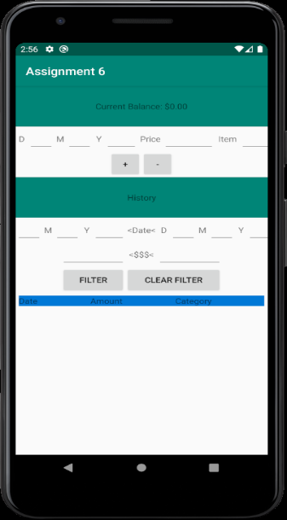

Step 2

Type the data in app

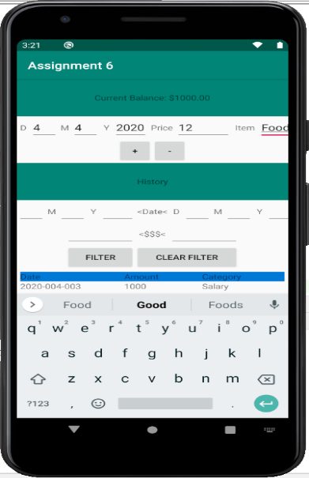

Step 3

Click the - bottom (If you get money you can click + bottom)

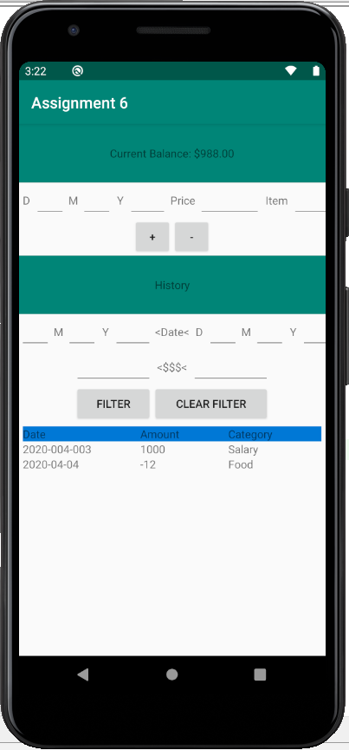

Step 4

Type in data more time

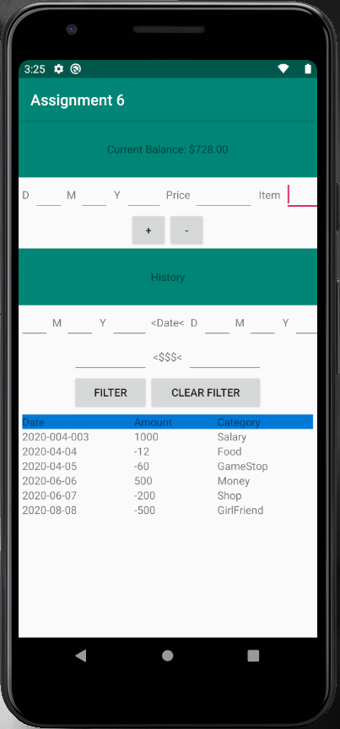

Step 5

Chose the date you want to research your bill history and click FILTER

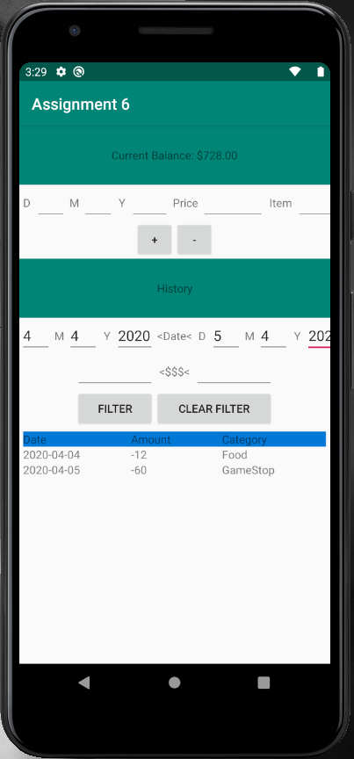

Step 6

Search a number of moneys you spend or save one times in history.

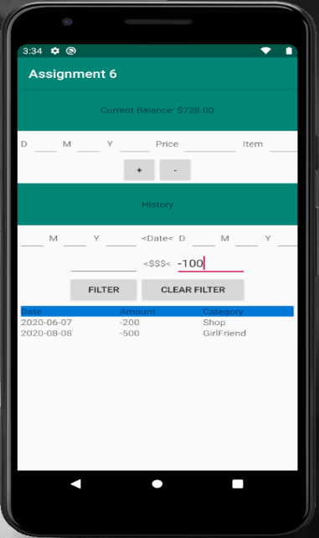

Step 7

Search a number of moneys you spend or save one times with the date you want to know.

